Types of Identical Rhyme
# Source: AI Source: Provided by: [Data Path: Persons Table -> ID Column: 1, Name_En Column: Motasem Essam] -> From: [Chatgpt (GPT-4-turbo)] on [8/2/2025]
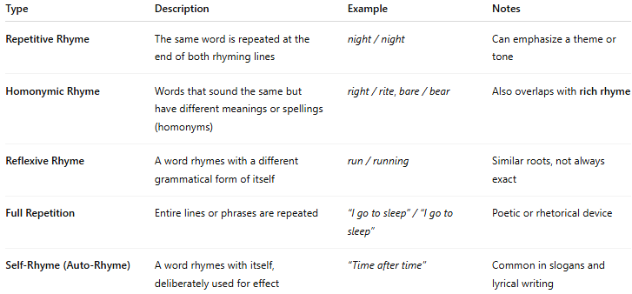

Type | Description | Example | Notes
Repetitive Rhyme | The same word is repeated at the end of both rhyming lines | night / night | Can emphasize a theme or tone
Homonymic Rhyme | Words that sound the same but have different meanings or spellings (homonyms) | right / rite, bare / bear | Also overlaps with rich rhyme
Reflexive Rhyme | A word rhymes with a different grammatical form of itself | run / running | Similar roots, not always exact
Full Repetition | Entire lines or phrases are repeated | “I go to sleep” / “I go to sleep” | Poetic or rhetorical device
Self-Rhyme (Auto-Rhyme) | A word rhymes with itself, deliberately used for effect | “Time after time” | Common in slogans and lyrical writing

